Facebook Status Updates



Copy and Paste These Status Updates For Your Facebook Clients To Help Them Get More Customer Interaction!
You can use Facebook’s ‘scheduling’ feature to line up as many of these posts as you like and have them posted over the next few weeks!

Quotes

- “Your time is limited, so don't waste it living someone else's life. Don't be trapped by dogma - which is living with the results of other people's thinking. Don't let the noise of other's opinions drown out your own inner voice. And most important, have the courage to follow your heart and intuition. They somehow already know what you truly want to become. Everything else is secondary.” – Like this if you AGREE!

- “Twenty years from now you will be more disappointed by the things that you didn't do than by the ones you did do. So sail away from the safe harbour and catch the winds in your sails. Explore, dream and discover”. – Like this if you AGREE

- “Businesses used to have a small suggestion box near the door that mostly housed dust bunnies and an occasional piece of gum. Rarely would someone get back to you. But people can now make a post from an Iphone or a BlackBerry while they’re sitting in your restaurant.” – Charles Nelson, President of Sprinkles Cupcakes president – Like, share or comment!

- “The secret isn’t growing a huge fan base. We have 100,000 Facebook fans, but those fans have all come to us organically. We believe the more organic the growth, the more loyal the fans, the more likely they will be repeat customers.” – Cam Balzer, vice president of marketing at Threadless

- “The only way to put out a social-media fire is with social-media water.” – Ramon DeLeon, managing partner – Like this if you agree!

- “There is nothing like a dream to create the future”.

- “If you cannot do great things, do small things in a great way.” – Like, share or comment if you agree!

- “Life’s real failure is when you do not realize how close you were to success when you gave up.” – Like if you feel inspired by this, or comment!

- We make a living by what we get, but we make a life by what we give. – Like to agree and share to give something!

- “There are no secrets to success. It is the result of preparation, hard work, and learning from failure.”- Like this status if you feel inspired!
Images With Captions


11.



12.



13.




14.

15.


16.


17.


18.


19.

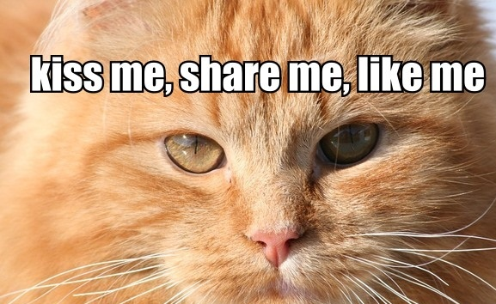

20.

Social Media Status Updates

21. Once this page gets 100 more likes, we are going to be posting a special offer for all our Facebook fans.
22. We are going to be posting a special offer on Wednesday. Make sure you keep your eyes peeled!
23. Did you know that Facebook has nearly 1 billion users – are you one of them?
24. Pinterest is the fastest growing social media website ever. Do you know what Pinterest is?
25. Have you ever bought something off Facebook?
26. If Facebook was a country it would be the third largest in the world.
27. Like this status if you are using Facebook from your phone.
28. Facebook or Twitter. Which one do you prefer?
29. How often do you check your Facebook?
30. How long do you spend on Youtube?

Brand Related Status Updates

31. Have you checked out our latest special offers yet?
32. Have you checked our Pinterest tab?
33. How did you find out about this page?
34. Have you grabbed our special offer yet?
35. Share this page on your wall, for a chance to win a FREE Ipad.
36. Does anyone have any suggestions on the cover for this Facebook page?
37. Have you clicked on our mailing list tab to join our mailing list?
38. Only 5 days left for our special summer sale. Be sure to check it out!
39. What is the best thing you like about this page?
40. Do you like logo 1 or logo 2? Comment below to give your feedback please, thanks!

Humorous Status Updates

41. Facebook needs a “drama of the day” section in my news feed.
42. The moment when you browse Facebook, see bitchy status updates *90 comments! *gets Popcorn”. This is going to be good!
43. How to freak someone out. 1. Find someone on Facebook with the same name as you. 2. Steal their profile picture. 3. Poke them!
44. We all used Facebook out of curiosity and ended it as an addiction.
45. Just read a really good book on how to improve your memory but I forgot the title.
46. That awkward moment when someone comment on your status has more likes than your actual status.
47. Don’t you wish it was easy to unfriend people in real life as it is on Facebook?
48. Miss a phone call. Call back thirty seconds later, they don’t answer.
49. The longer the title, the less important the job.
50. I thought I wanted a career, turns out I just wanted paychecks….

